Q1.Describe the working of Scrum with suitable example.

Ans:

Scrum is an agile project management framework that is used to deliver products in short cycles called sprints. Sprints are typically two weeks long, but can be shorter or longer depending on the project. At the beginning of each sprint, the team plans what they will work on and by the end of the sprint, they have a working product increment.

Scrum is a very effective framework for delivering products in a timely and efficient manner. It is also a very flexible framework that can be adapted to fit the needs of any team.

**Scrum is based on the following principles:**

* Transparency: All work is visible to everyone on the team.
* Inspection: The team regularly inspects their work to identify and address any problems.

Example

Imagine you're planning a surprise birthday party for a friend. Scrum can help make it awesome!

* **Roles:**
* **You (Product Owner):** You have the coolest ideas for the party, like games, decorations, and a special cake. You make a list of these things (backlog).
* **Friend 1 (Scrum Master):** This friend helps keep everyone organized and makes sure you follow the plan (Scrum ceremonies).
* **The Team (You and your other Friends):** Everyone has different skills! Some are great at baking, decorating, or finding fun games. You'll work together to throw the perfect party.
* **Party Planning in Stages (Sprints):** Instead of trying to do everything at once, you decide to work in short weeks (sprints). Each week, you focus on a small set of tasks from the list (backlog), like buying decorations or planning games.
* **Quick Check-ins (Daily Scrum):** Each day, you have a short meeting (5-10 minutes) to discuss:
* What you accomplished yesterday (completed tasks for the party).
* What you'll work on today (next steps, like baking the cake).
* Any problems you face (like forgetting the streamers!).
* **Showing Off (Sprint Review):** After each week (sprint), you have a quick meeting to see what's ready (working product). Maybe you show off the finished decorations or taste-test the cake!
* **Learning and Adapting (Sprint Retrospective):** Before starting the next week, you have a chat as a team. You discuss:
* What worked well (e.g., everyone brought ideas).
* What could be better (e.g., maybe assign tasks in advance).
* How to improve for next week (adaptation).

By working in short bursts, checking in regularly, and adapting your plans as needed, you can throw a fantastic surprise party with your friends using Scrum!

Q2: What is Audit? Explain the roles and responsibilities of formal audit

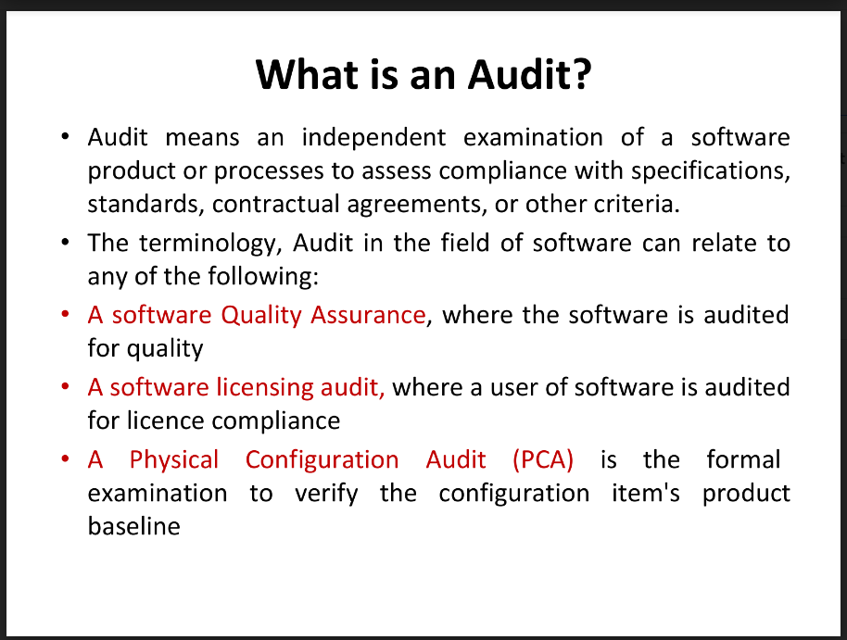

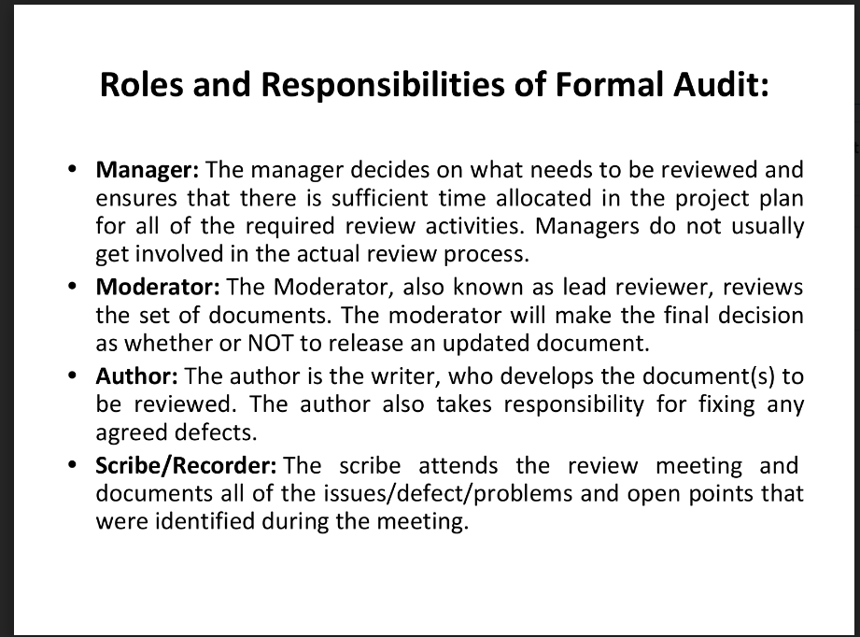

auditors may be hired internally by the company or work for an external third-party firm. Almost all companies receive a yearly audit of their financial statements

Audits are like independent reviews to ensure things are being done correctly and fairly.

An audit is a systematic and independent examination of an organization's financial information, records, operations, or processes.

Agile methodologies

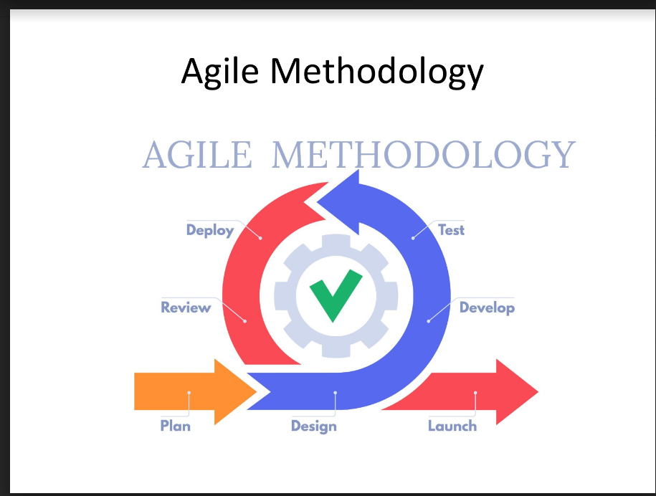

Sure, the image you sent depicts a common agile methodology workflow. Agile methodologies are iterative and incremental approaches to project management, typically used in software development. They focus on continuous collaboration, adaptation, and delivering value early and often.

Here's a breakdown of the agile methodology stages illustrated in the image, along with a real-world example to understand them better:

**Imagine you're building a mobile app to order food delivery from various restaurants.**

* **Plan:**
* This initial stage involves defining the project scope and creating a product backlog, a prioritized list of features for the app. In our example, the backlog might include features like user registration, restaurant browsing, menu selection, order placement, and online payment.
* **Design:**
* Here, the team translates the requirements from the backlog into user interfaces (UI) and user experiences (UX) designs. This ensures the app is user-friendly and meets user needs. In our example, the team would design screens for browsing restaurants, viewing menus, and placing orders.
* **Develop:**
* The development team works on building the features prioritized in the backlog. They might use short sprints (1-4 weeks) to deliver a functional set of features in each iteration. For the food delivery app, this could involve developing functionalities for user registration and restaurant browsing in the first sprint.
* **Test:**
* After each development sprint, the team rigorously tests the features to identify and fix bugs. This ensures the app functions as intended and meets quality standards. In our example, the team would test the user registration and restaurant browsing functionalities to ensure they work seamlessly.
* **Deploy:**
* Once features are developed and tested, they are deployed to a production environment, making them accessible to end-users. In our example, this could involve deploying the initial version of the app with user registration and restaurant browsing features to a limited audience for beta testing.
* **Review:**
* After each deployment, the team gathers feedback from users and stakeholders. This feedback is used to improve the product and identify new features or functionalities to incorporate. For the food delivery app, the team would gather feedback on the user registration and restaurant browsing features to see if there are any improvements to be made.
* **Launch:**
* Based on feedback and testing, the final version of the product is launched to the public. For the food delivery app, this could involve a public launch of the app after incorporating user feedback and addressing any bugs.

**Key aspects of Agile Methodology:**

* **Iteration:** The project progresses in short, iterative cycles, allowing for continuous improvement and adaptation based on feedback.
* **Collaboration:** There's a strong emphasis on collaboration between team members, product owners, and stakeholders.
* **Flexibility:** Agile methodologies are adaptable to change. New features or priorities can be incorporated throughout the development process.
* **Continuous Delivery:** The goal is to deliver working software frequently, enabling early feedback and reducing risks.

Overall, agile methodologies provide a framework for software development projects that can adapt to changing requirements and deliver value quickly.

Q 3 Elaborate Iterative Project Management Life Cycle with neat diagram.

Q 4 Elaborate Adaptive Project Management Life Cycle with neat diagram.

<https://www.izenbridge.com/blog/project-management-life-cycle-iterative-adaptive/>

Q 8Compare between Procedural approach and Quantitative approach in Quality Management(any 4)

